Main Instructions
for
Voices Around The World 2016

Lighting Up The Flame

Write your VATW username and password here
Username:
Password:

Introduction

Voices Around The World 2016 'Lighting Up The Flame!'
Voices Around The World is a free project with a mission to help young people everywhere work together musically. This year the youngsters involved will be part of making an international release of the song Lighting Up The Flame written especially for the project by Laurie Lewin. We also ask schools to record the students at work on the project with short video clips and photos that we can use in the final audio/video version we release.
This short booklet gives you all the information needed for different parts of the project. We hope it helps make things straightforward. We recommend that you print out these instructions and keep them for future reference.
The Main Components of the Lighting Up The Flame Project
- Rehearsing, recording and submitting group vocals to be part of the international recording
- Recording any strong solo singers individually – we hope to feature some of these individuals on this year’s final mix.
- Making and submitting short video clips/photos of your students rehearsing, recording and/or performing the music.
- If possible, linking with other schools nearby you to get them involved in the project.

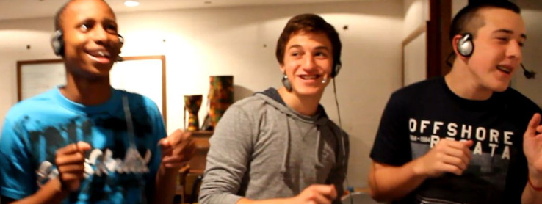
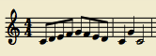
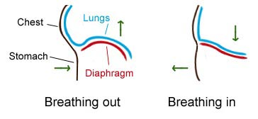
Section 1 – The SingING
Singing tips

It’s really important to allow your singers to warm up their voices before the rehearsal begins. Choose a variety of different starting pitches so that both low and high voices can be warmed up. Here are a few different exercises that you could try…

Singing up and down (or down and up) a major scale using tricky words or tongue twisters – try singing each set of words or each tongue twister to one note at a time. (eg: “Red lorry, yellow lorry” or “Chicken Tikka” or even vowel sounds “A-E-I-O-U”). The more the words move the mouth around, the better!

Singing ‘la’ to a major scale that ascends for five notes, descends back to the starting note
and finishes with three final ‘la’s on the first, fifth and then first note of that scale.

Singing an octave major scale, up and down, using numbers in a pattern. The pattern starts with ‘one’ and adds a number each time, going all the way up to eight. The complete pattern is sung to the corresponding notes in the scale: 1, 1-2-1, 1-2-3-2-1, 1-2-3-4-3-2-1, 1-2-3-4-5-4-3-2-1 etc. Once you have reached ‘eight’, try starting from the end of this pattern and working your way back to the beginning: 8, 8-7-8, 8-7-6-7-8 etc.

It is useful to project the song words onto a board whilst your singers are learning the song. This will ensure that they are looking up, keeping tuning accurate and looking at you – use the downloadable ‘karaoke’ choir part videos from our website www.voicesaround.com The sooner your students know the words by heart the better – it is far easy to teach dynamics once they know the words!

Teach the song in small sections. Ensure that a section of the song is strong and secure before you move onto the next.

A “call-and-response” technique may be useful so that singers can copy you to learn the song.

Always try to keep the rehearsal calm and focused. If you have different voices or parts in your choir, make sure that groups who are not talking whilst one part is rehearsing.

Make sure that rehearsals are not too long. A loss of energy and focus may mean that time has not been used effectively.

If possible let students have access to the downloadable ‘karaoke’ rehearsals videos mentioned above – so that they can learn their choir parts individually at home – this will really speed up your rehearsals!

Make sure your singers breathe in the same places to make the recording sound as “clean” as possible.

Correct breathing involves the diaphragm moving in and out – singers should not move their shoulders to breathe and should rather keep them very still. You can show this to your
singers by asking them
to practice breathing
whilst placing their hand
on their diaphragm.

It’s important that all words are pronounced clearly and that words ending with ‘S’ or ‘T’ are brought off at the same time. Ask singers to watch you for this.

Ask your singers to stand up (straight) when they sing to create the best sound possible. This will also significantly improve tuning.

Eyebrows can also help tuning! If your singers are flat, ask them to raise their eyebrows whilst they are singing. This will literally make them think “up” and will lift the intonation.

WARM UP IDEAS
Breathing & Diction
Intonation
TEACHING THE SONG
Keeping in sync
The key to the success of this project is the synchronisation of the choir vocals from all of the participating choirs. We cannot stress enough how important this is. You need to therefore ensure that you follow the instructions below very, very carefully.
Additional rehearsal important points
It is very important that you stick to the choir MP3 versions. Make sure that your students have plenty of opportunity to sing along with these parts so that they are as closely in sync as possible with the voices on the demo tracks. While it will of course be the voices of all the choirs involved that will feature on the final recording, getting the voices in sync with the demo track voices is the template for ensuring that all choir recordings we eventually receive will be in sync with one another.

Key teaching tip: One very useful rehearsal strategy, is to provide your choir with individual electronic copies of their choir parts or let them download choir parts/karaoke videos so that they can practice at home etc. We have found this method very successful in the past for helping students quickly learn different choir parts – it will really speed up your rehearsals!
How to make the recording(s)
We hope you have got/and will get much pleasure out of rehearsing and performing the song. However, the recording sessions call for a different approach and one that needs a good deal of forethought and planning in order to get the best results. The work will require much rigour – calling upon the greatest amount of precision possible from your singers. While it will be lots of hard work, generally we find students enjoy the recording part – as they feel a bit like ‘pop stars' and a bit like they are appearing on the X Factor! You will also thank us afterwards because the resulting quality of your choir’s singing will be awesome as a result of the rigour to which they have been subjected!
We will only be able to include choir recordings on the final master recording that have reached a reasonable standard and, as stated before, recordings being in sync with the supplied choir MP3s is the most crucial factor. We are sure that all of you will manage this!
Getting used to singing while wearing earphones
This requires practice. Many people/students find this hard at first especially as they cannot hear their own voice in the same way as usual and this can raise vocal tuning issues. This improves with practice. It may be useful for some students to experiment with pulling one earphone off on one side so that they can hear their own voice and the voice of others while they sing. If you look at the VATW site photos page you will notice some students doing just this!

Earphone leakage
This is when the sound from earphones is picked up by the microphone you are using i.e. in this case the guide demo track your students are listening to while they sing, is picked up on the recording. Try to eliminate/reduce this as much as you can. It is obviously made worse when the students are close up to the microphone. The more you can reduce this the better the quality of the recording for mixing on to the final track.

Fool proof recording
This feels a little like stating the obvious, but it is worth reminding ...... that when recording choir parts, make sure your students are listening to the demo track as a guide. To inspire yourselves before you record you could enjoy watching the YouTube video of the studio session for recording ‘We Are The World’. This is a great resource and makes a superb music quiz for older students …can they recognise these icons of the music industry …..you are helped by the credits rolling at the end of the clip! http://youtu.be/M9BNoNFKCBI

How to get as close to a ‘pure voice’ sound as possible
We need the voices of your choir to put on the final master recording. This means that your recording(s) should only be voices! In other words, we do not want a recording of your choir that includes the backing track in the background. This would lead to quite an unpleasant sound when we come to put all the recordings together – making the final mix. We want you to set up your recording so that the students listen to the backing track on earphones while singing. This of course pretty much mirrors the way it is done in professional recording studios. ‘WOW that sounds difficult’ we hear you say! NO not at all....here is what you do:
1. Ensure you have reasonable quality recording equipment. A basic microphone and recorder should do the job. Nowadays, these pieces of equipment are easily available at reasonable prices if you do not already have them. You may find somebody in your school parent community who can help out.
2. You need to have sets of earphones and a junction box/junction boxes....the more the merrier! See the picture of a typical junction box below ... this feeds from the sound source where you are playing the choir part MP3s while the students sing.

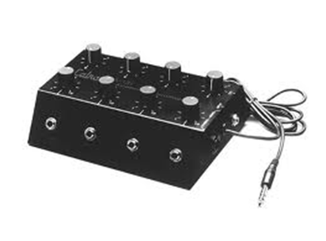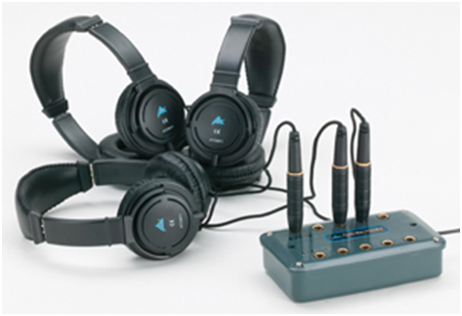
This approach means that you can record groups of your choir singing ...the number of groups you record will depend upon the number of earphones you have available ... the more earphones you have ....the fewer the groups. Working in this way means that when you record, your singers can hear the music backing, but the recording only captures their voices. Within reason we are happy to accept any number of recorded groups from you. All of your recording submissions should be in wav file or MP3 format.
Recording groups.
The groups that you record will require some forethought. The obvious format is to require different sections of your choir. However, you will inevitably have some variations in the quality/confidence of your singers. We have sometimes found ourselves breaking sections down i.e. a stronger section of the best singers recorded, then other groups where some of the best singers support the singing of less confident individuals.
Soloists
Yes please - We are happy to receive recordings of soloists if you have some especially high quality individuals - this gives us the scope in the mixing process to bring a few individual voices to the foreground of the mix if appropriate – this is an aspect that we hope will feature in this years final for 2016.
Here is an imaginary example of a recording plan of a choir. The music teacher has sorted out soloists, strong groups and groups that need support
The altos are the first section to record, and they listen to and sing along with their relevant choir MP3 part, aligning their voices with Howard’s as closely as possible. The other choir sections follow on in the same way.

Choir sections | Recording Track
Part 1 – group a | 1 wav audio recording
Part 1 – group b | 1 wav audio recording
Part 1 - 2 individual solo recordings | 2 wav audio recordings
Part 2 group a | 1 wav audio recording
Part 2 group b | 1 wav audio recording
Part 2 group c | 1 wav audio recording
Part 2 - 3 individual solo recordings | 3 wav audio recordings
Part 3 group a | 1 wav audio recording
Part 3 group b | 1 wav audio recording
Part 3 – 2 solo recordings | 2 wav audio recordings
How to get the best sound - the recording environment
It is well worth choosing the room in which you record very carefully. Smaller rooms with soft furnishings will often give the best results.
Microphone placement - The distance of your singers from the microphone is important and it is worth experimenting with this a little. It varies a bit from microphone to microphone. Successful recordings we have done in the past have been with students arranged in a semicircle around the microphone so that they are all a similar distance away. About a metre from the microphone is often about right for choir work. It will be good if you are able to monitor the sound levels and quality using earphones yourself, and adjust choir positions/proximity to the microphone accordingly. In particular watch out for any singer with a much louder voice than others and adjust their standing position if necessary. You may find this problem is exacerbated because students may sing differently with earphones on (known as the IPod syndrome!). Be careful that you do not ‘over record’ i.e. have a recording level that causes distortion of any sort – this would make the recording unusable for us.
Key teaching tip: Your singers do not have to sing loudly
The joy of audio recordings with microphones is that you do not need to sing loudly – pitch and tone are far more important. The volume of your singers can of course be boosted by the recording equipment as necessary. As mentioned above ‘over recording’ and distortion are the main ‘enemies’. In the process of finally mixing vocal submissions we can usually work with recordings that were rather low volume – boosting the volume with our studio equipment. Sadly there is very little that can be done with distorted/over recorded submissions.
Extraneous noise.
You will need to take care that there are no extra sounds on the recording. There are many hazards in any school environment for someone trying to make a recording! Typical problems can be school bells, kitchen or air conditioning equipment and …..of course …PEOPLE! We have had some interesting recording sent in at times…one actually had chickens clucking in the background!

Specific teaching points for Lighting Up The Flame
- We deliberately avoided using the traditional terms alto, soprano etc. for the choir parts this year. This is to ensure maximum flexibility for you in matching the song parts we provide for your different student groups – abilities and age ranges. For example, you will notice on the demo track that the students are sometimes singing the same song parts but different octaves and this is absolutely fine. If the note range is too high for a specific part for your students – try the same tune an octave lower and vice versa.
- Note sliding. Wherever possible get your students to hit the notes accurately and avoid the habit of sliding up to or down to a note. Good breathing is often the secret of success in this respect.
- The singing rhythm is quite ‘punctuated’ in this song. You may find it helpful to get your students speaking the words together during practice to ensure they are using the precise rhythm as shown in the score and on the demo recording.
Key teaching tip: Get students to listen to the strong pumping base line in the song and ensuring they are in time with this and the demo vocals on the MP3s
How to submit your recording(s) - Uploading your choir recording(s) to Dropbox
Success! You have managed the recording and are all feeling pretty pleased with yourselves …and rightly so! Now the puzzle of how to submit these valuable recordings to us!
Firstly to say - please, please, please do not send the recordings by email. This method could lead to a serious 'logjam' on our server.
One of the best systems we have come across for sharing recordings/files is the Dropbox system. This is a free internet programme. If you are not already a member of Dropbox, simply go to their website https://www.dropbox.com/ and download their software and you will be ready for action.
Downloading the Dropbox software
Setting up your folders
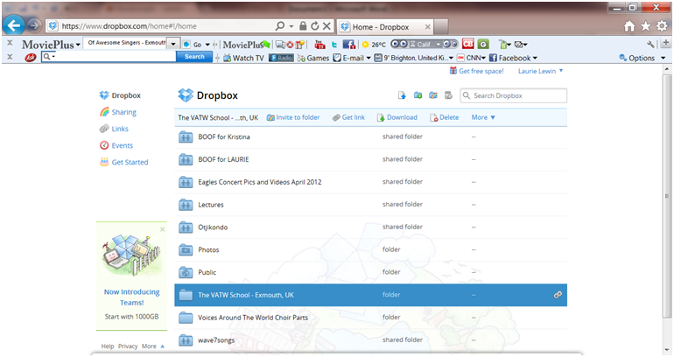
This is a snap of our current Dropbox. We have lots of folders, but you only need one for this project. Simply click on the add folder option in the menu at the top of the screen. It is very important that you clearly label your folder. This is how we will identify your school choir. You will see on the screen snapshot above, we have created an example folder called ‘The VATW School – Exmouth, UK.’

Uploading your files
Whatever device you have used to record your choir parts, you will need to save the audio files onto the computer on which you have installed Dropbox. You can then save your audio files easily to Dropbox. Those of you who are pretty ‘wizzy’ with things ICT will have realised that Dropbox cleverly creates a folder space on your computer as well as on the web. Whatever you copy to the Dropbox folder on your computer, provided you are connected to the internet, automatically gets copied onto your web Dropbox Folder and vice versa. Warning: remember the same applies to deleting folders!!!
Key teaching tips: Make sure you are connected to the internet when saving files to Dropbox (sorry – obvious….but sometimes missed!). Once uploaded – please do not delete files until after the project has ended for this year
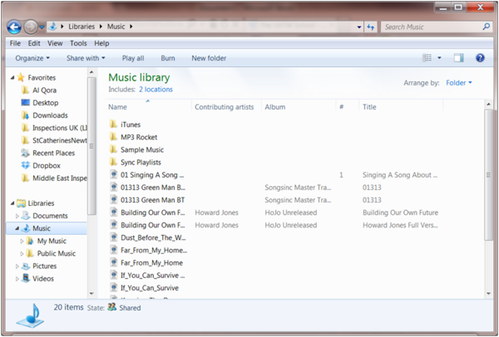
So just go ahead now and save your choir recordings to Dropbox on your computer. (Make sure you are connected to the internet.) We recommend keeping a backup somewhere safe of your choir recordings in case of computer crashes etc.
By now you should have something like the screenshot below shows. The final step is to share your files with us so that we can download them.
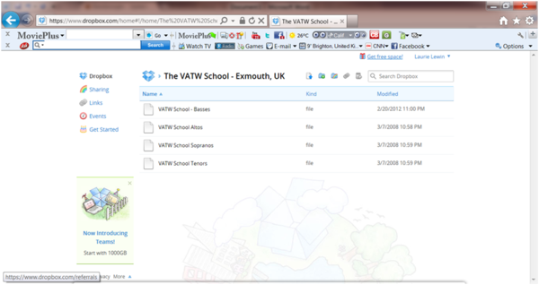

Sharing your folders with us
As indicated, click on the rainbow coloured icon. And you will get the screen below opening:
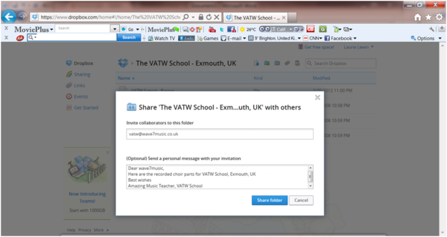
You need to put the email address voices@voicesaround.com in the first box and any relevant message in the box below – to show which school you are.

Labelling the files that you send to us
It is a very big job here at VATW collating all of the tracks and files that get submitted to us. It is enormously helpful if you name your file/files using the following example:
Name_of_School/s_in_full_Town_Country_Part1

To submit your video to us please follow the Dropbox instructions above.

Section 3 – Working with another school/Schools
Over the last four years, we heard some very encouraging stories about schools that had linked with other schools for the project and produced some amazing results and carried out some great joint activities together. We want this idea to grow. For example, The students at the International School of Riga in Latvia told us how they did much work with a Latvian Orphanage organisation and would like to bring this particular organisation into working on the song with them this year. We very much hope that in working on the project this year you will be able to achieve something similar. Please let us know of any collaboration of this nature when you submit your recordings in March 2015.

