Verse 1
I look around the world
It seems we’re in a race
Why does it have to be
Such a complicated place
I listen to the news
You know it makes me sad
Those crazy politicians
Driving people mad
They take away the trees
They take away the land
Destroying all the forests
It’s hard to understand
They’re drilling for more oil
Every single day
We turn it into plastic
And throw it all away
What kind of world are we trying to make?
What kind of World are we trying to make?

Chorus
Is this the way we want everything to be
Is this the future that we really, really want to see
Or can we learn to dance a different kind of dance today
Give ourselves a chance …Find ourselves a better way

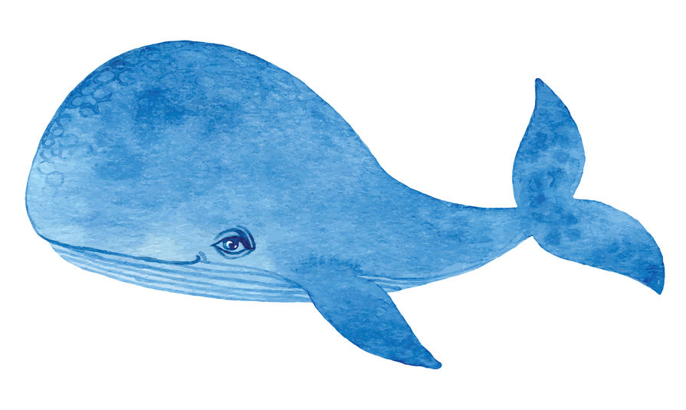
This is Wally The Whale. If you listen carefully you can hear him singing at some parts of the song.

He is singing about how worried he is about the pollution in the oceans.

Verse 2
All these smoky chimneys
They’re messing up the air
The climate keeps on changing
Does anybody care
The beauty of our planet
It’s just a distant dream
They’re poisoning the rivers
They’re poisoning the streams
The Piper plays his tune
And we all dance along
There is no real rhythm
There is no real song
We need some different music
And learn to dance again
We’re lost out in the wilderness
Sleep walking ‘til the end
What kind of world are we trying to make?
What kind of World are we trying to make?
Chorus

Is this the way we want everything to be
Is this the future that we really, really want to see
Or can we learn to dance a different kind of dance today
Give ourselves a chance …Find ourselves a better way

Outro
We’re gonna find a better way to …day
We’re gonna find a better way to …day
We’re gonna find a better way to …day
We’re gonna find a better way!

